Birla Institute of Technology & Science, Pilani
Work-Integrated Learning Programmes Division
Second Semester 2024-2025

Comprehensive Examination
(EC-3 Regular)

Course No. : DE ZG561
Course Title : MECHANISMS AND ROBOTICS
Nature of Exam : Open Book
No. of Pages = 2

No. of Questions = 5
Weightage : 40%
Duration : 2 Hours
Date of Exam :
Note:
- Please follow all the Instructions to Candidates given on the cover page of the answer book.
- All parts of a question should be answered consecutively. Each answer should start from a fresh page.
- Assumptions made if any, should be stated clearly at the beginning of your answer.

Q.1. | Three identical SRS open-chain arms are grasping a common object, as shown in Figure 1. Find the degrees of freedom of this system.  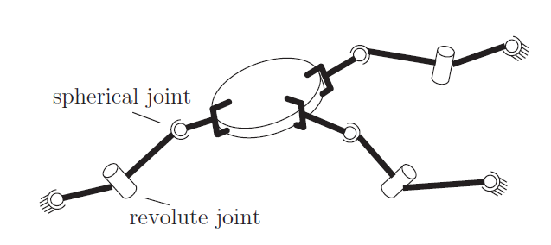  Figure 1 | [6]
Q.2. | Given the geometric conditions, write a program for moving a cylindrical object of height 150 mm from point P1 to point P2. Make suitable assumptions.  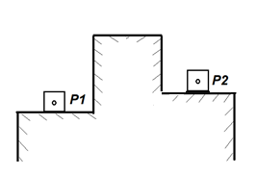  Figure 2 | [6]
Q.3. | A joint of a robot is rotated from 30 °to 90 ° in 10 seconds with a cruising velocity of 8 deg./second. Find the blending time using parabolic blending and plot joint positions velocities and accelerations. | [8]
Q.4. | List the steps in using an H-bridge is achieving position control of a link. | [4]
Q.5. | Compute the Manipulator Jacobian for the 3-axis robotic arm shown in the figure. The position of the tool point P given as follows.  $$P=\left[\begin{matrix}cosθ_{1}[(L_{3}+d_{3})cosθ_{2}-L_{2}sinθ_{2}] \\ sinθ_{1}[(L_{3}+d_{3})cosθ_{2}-L_{2}sinθ_{2}] \\ L_{1}+L_{2}cosθ_{2}+{(L_{3}+d_{3})sinθ}_{2}\end{matrix}\right]$$  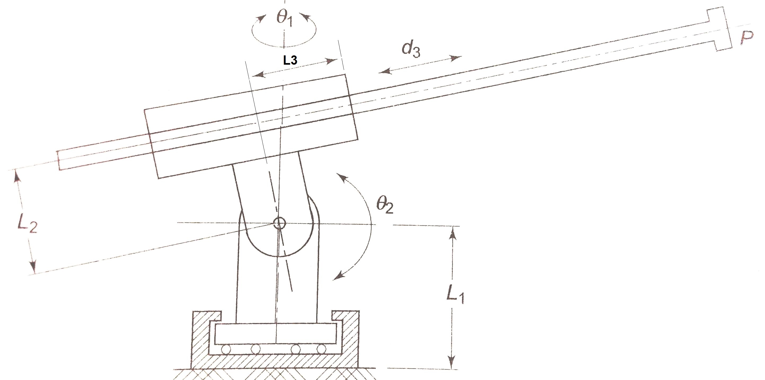  Figure 3  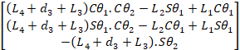 | [8]
Q. 6. | Two links with the same mass m, pivoted at points $O_{1}$ and $O_{2}$ are shown below. Select the link in which the dynamic torque will be minimum and derive the dynamic torque equation using the Lagrange-Euler dynamic model.  Figure 4 | [8]
  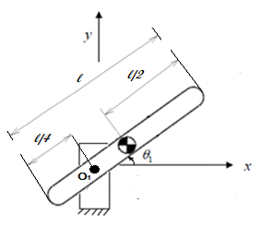  (a) | 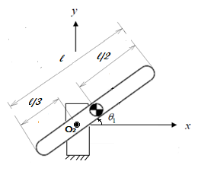  (b)

***********

